**PIZZA SALES SQL QUERIES**

KPI’s

1. Total Revenue:

select sum(total_price) as Total_Revenue from pizza_sales

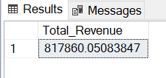

1. Average Order Value:

select sum(total_price)/count(Distinct(order_id)) as Average_Order_Value from pizza_sales

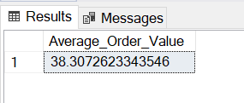

1. Total Pizzas Sold:

select sum(quantity) as Total_Pizzas_Sold from pizza_sales

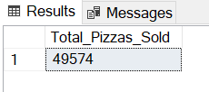

1. Total Orders:

select count(Distinct(order_id)) as Total_Orders from pizza_sales

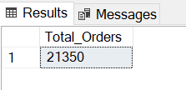

1. Average Pizzas Per Order:

select Cast(Cast(sum(quantity) as decimal(10,2))/Cast(count(distinct(order_id)) as decimal(10,2)) as Decimal(10,2)) as Average_Pizzas_Per_Order from pizza_sales

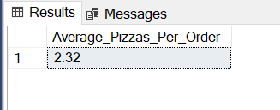

Chart Requirement

1. Daily Trend for Total Orders:

Select DATENAME(DW, order_date) as Order_day, count(Distinct order_id) as Total_Orders

from pizza_sales

group by DATENAME(DW, order_date)

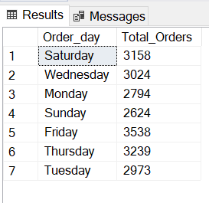

1. Monthly Trend for Total Orders:

Select DATENAME(MONTH, order_date) as Month_name, count(Distinct order_id) as Total_Orders

from pizza_sales

group by DATENAME(Month, order_date)

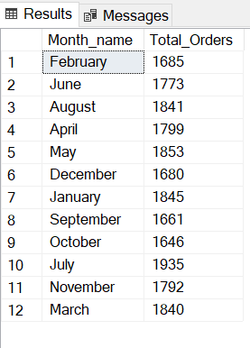

1. Percentage of Sales by Pizza Category:

select pizza_category,sum(total_price) *100/(select sum(total_price) from pizza_sales) as PCT

from pizza_sales

group by pizza_category

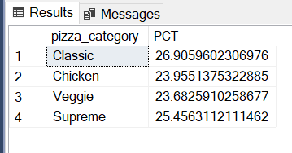

1. Percentage of Sales by Pizza Size:

select pizza_size,sum(total_price) *100/(select sum(total_price) from pizza_sales) as PCT

from pizza_sales

group by pizza_size

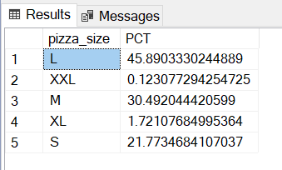

1. Total Pizza Sold by Pizza category:

select pizza_category,sum(quantity) as Total_Quantity

from pizza_sales

group by pizza_category

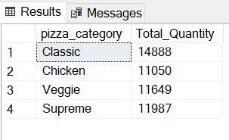

1. Top 5 Best Sellers By Revenue:

select Top 5 pizza_name,sum(total_price) as Total_Revenue

from pizza_sales

group by pizza_name

order by Total_Revenue desc

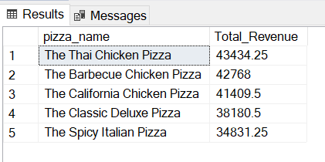

1. Bottom 5 Best Sellers By Revenue:

select Top 5 pizza_name,sum(total_price) as Total_Revenue

from pizza_sales

group by pizza_name

order by Total_Revenue asc

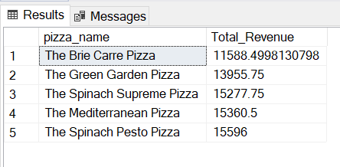

1. Top 5 Best Sellers By Quantity:

select Top 5 pizza_name,sum(quantity) as Total_Quantity

from pizza_sales

group by pizza_name

order by Total_Quantity desc

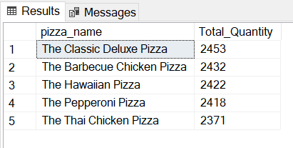

1. Bottom 5 Best Sellers By Quantity:

select Top 5 pizza_name,sum(quantity) as Total_Quantity

from pizza_sales

group by pizza_name

order by Total_Quantity asc

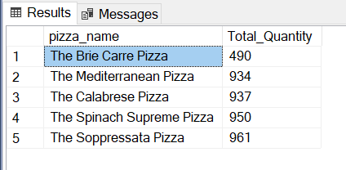

1. Top 5 Best Sellers By Orders:

select Top 5 pizza_name,count(Distinct order_id) as Total_Orders

from pizza_sales

group by pizza_name

order by Total_Orders desc

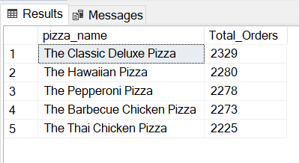

1. Bottom 5 Best Sellers By Orders:

select Top 5 pizza_name,count(Distinct order_id) as Total_Orders

from pizza_sales

group by pizza_name

order by Total_Orders asc

